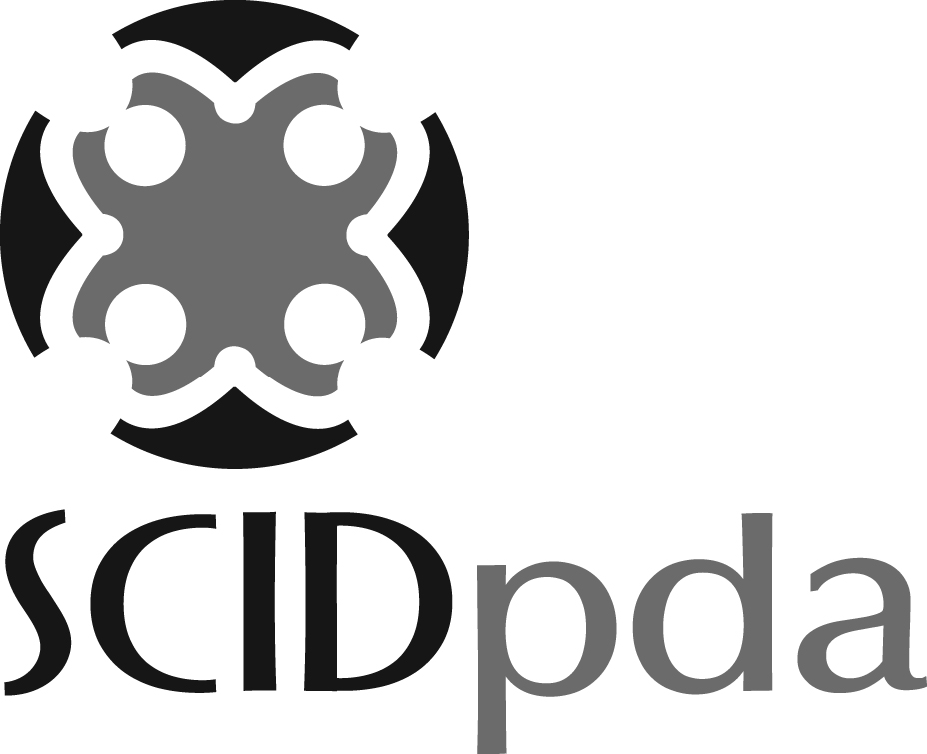

The mission of the Seattle Chinatown International District Preservation and Development Authority (SCIDpda) is to preserve, promote and develop the Chinatown international District (CID) as a vibrant community and unique ethnic neighborhood through its programs and services. For more information refer to www.SCIDpda.org.

Currently there is 1 full-time Therapy Rehabilitative Aide position open with Senior Services’ Legacy House, a program of the SCIDpda. The hours are Monday - Friday from 9:30AM – 5PM

Reports To: Occupational Therapist

FLSA Status: Non-Exempt Full-time (40 hours per week)

General Nature & Scope: This position provides service to the clients enrolled in the Adult Day Health program.

Essential Duties: Include the following; other duties may be assigned depending upon project, client or workflow needs.
- Assists in carrying out therapy program services specific to each client's needs under the supervision of the Occupational Therapist
- Follows specific treatment goals for each client as defined and updated by the Occupational Therapist on a quarterly basis
- Maintains accurate records of clients' daily attendance
- Provides accurate input with documentation of weekly notes
- Reports directly to and receives training for above essential duties directly from the Occupational Therapist
- Maintains and keep treatment areas clean and safe
- Works closely with Case Managers to coordinate clients' needs
- Participate in ADS team meetings
- Attend weekly multidisciplinary meetings

Supervisory Responsibilities: None

Qualifications: To perform this job successfully, an individual must be able to perform each essential duty satisfactorily. The requirements listed below are representative of the knowledge, skill, and/or ability required. Reasonable accommodations may be made to enable individuals with disabilities to perform the essential functions.

Knowledge, Skills, and Abilities

Education & Experience: Any combination of experience and training that would likely provide the required knowledge, skills and abilities will be considered.

- Asian language skills recommended
- Experience working with seniors and the disabled
- Ability to read and communicate well in English
- Minimum HS, some coursework and training in related field desirable
- Basic knowledge of diseases of older people
- Experience working with groups
- Able to relate effectively to clients from diverse cultural backgrounds
- Able to work independently with attention to clients' safety
- Able to provide physical assistance

Licenses or Certificates:
- First Aid and CPR certificate (must be obtained within 1 year of hire)

Physical Demands / Working Conditions: The physical demands here are representative of those that must be met by an employee in a business office environment to successfully perform the essential functions of this job. Reasonable accommodations may be made to enable individuals with disabilities to perform the essential functions of the job.
- Work is performed mostly in an environment with a low to medium noise volume. While performing the duties of this job, the employee is frequently required to read, speak, stand, walk, sit, observe and provide assistance to the clients.
- Must be able to walk two miles daily
- Must be able to lift up to 30 pounds and push up to 50 pounds
- Must be able to lift, carry, stand, bend, squat, reach, and kneel using good body mechanics for sustained periods of time and sometimes repetitively.
- Must possess information using sight/hearing senses, or use prosthetics that will enable these senses to function adequately so that the requirements of this position can be fully met
- Must be in good general health and demonstrate emotional stability in order to cope with the physical, mental and emotional stress of the position
- Position is sometimes exposed to body fluids, infections and odors.

